Hardware Implementation

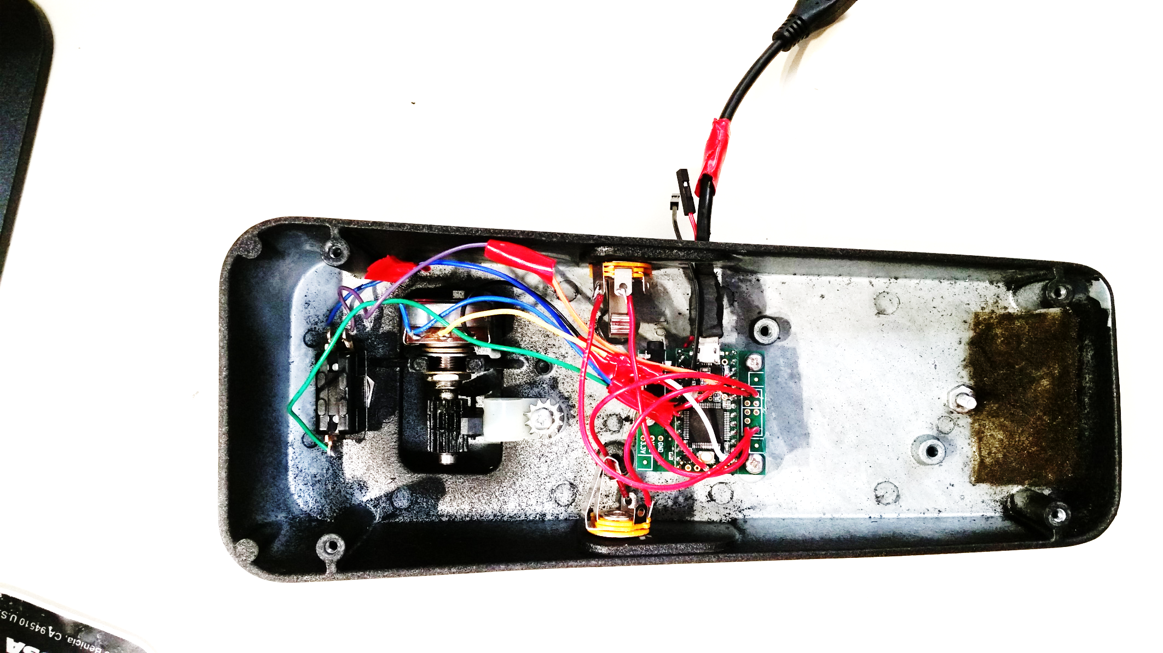

Switch

¼” Audio Jacks

Potentiometer

Power Supply Input

USB Cable

Teensy 3.2 and Audio Board Extension